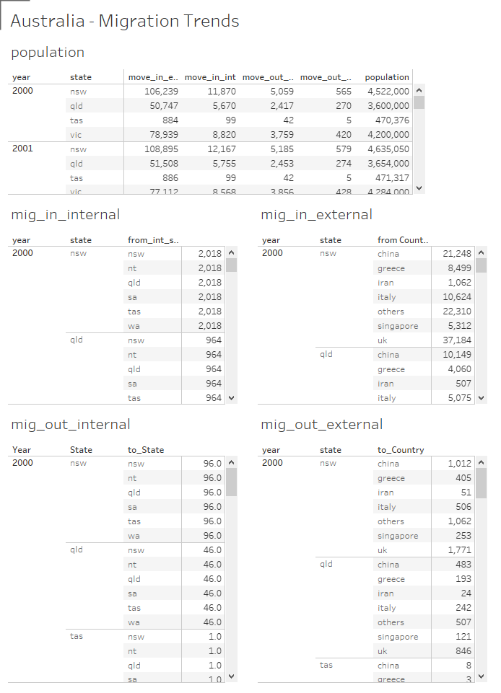

Critique:

* Is not very visual
* Takes space
* Need to scroll through the details
* Difficult to comapre

Strength:

* Can be implented easily
* Has all of the data
* Easy to read

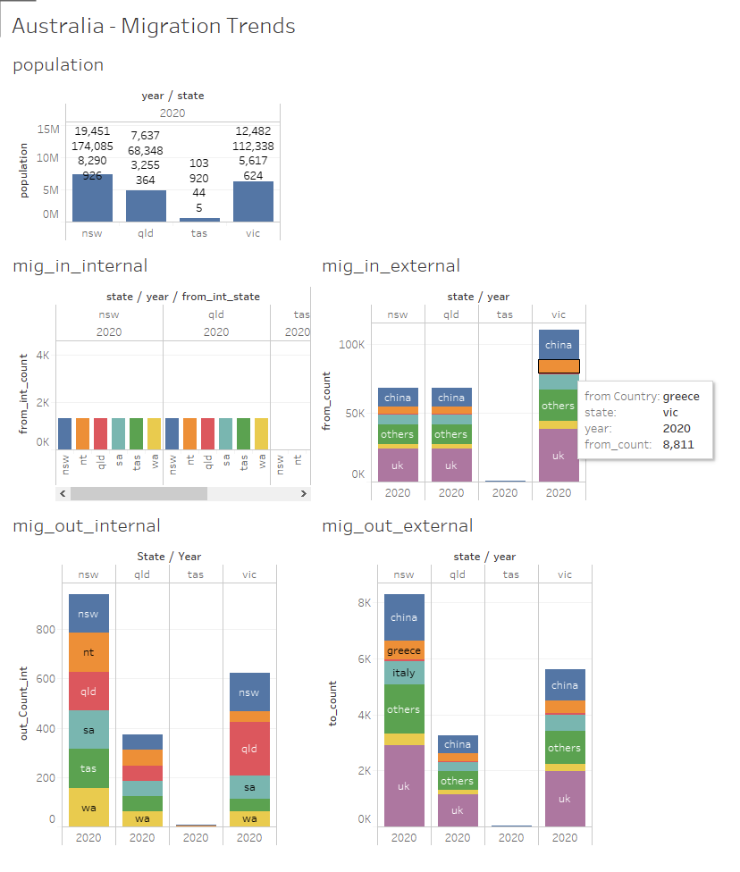

Critique:

* Filtered to a year
* Need to hover to see the details

Strength

* Visually improved with colours
* Can compare across states and countries easily

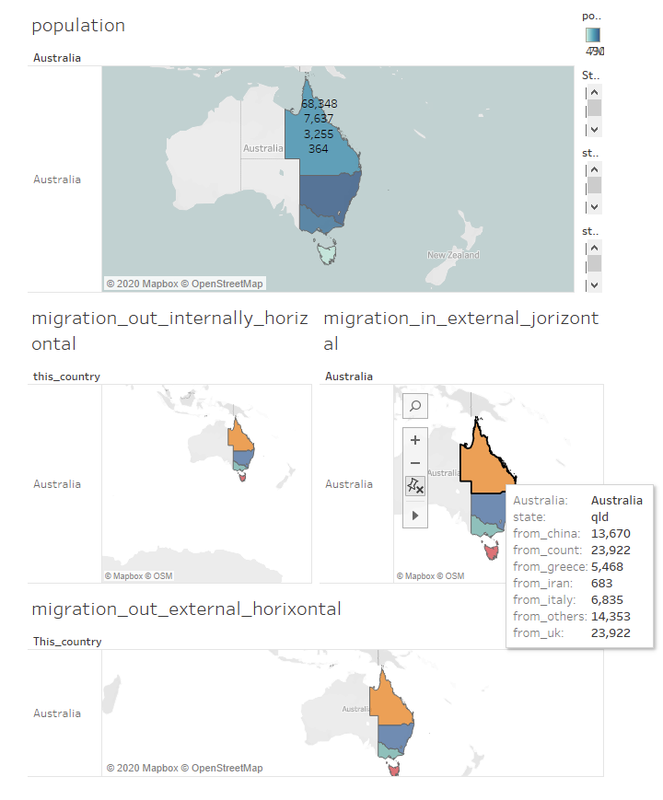

Critique

* Similar to the above
* Takes too much space for not a lot of value

Strength:

* Geographic visualization

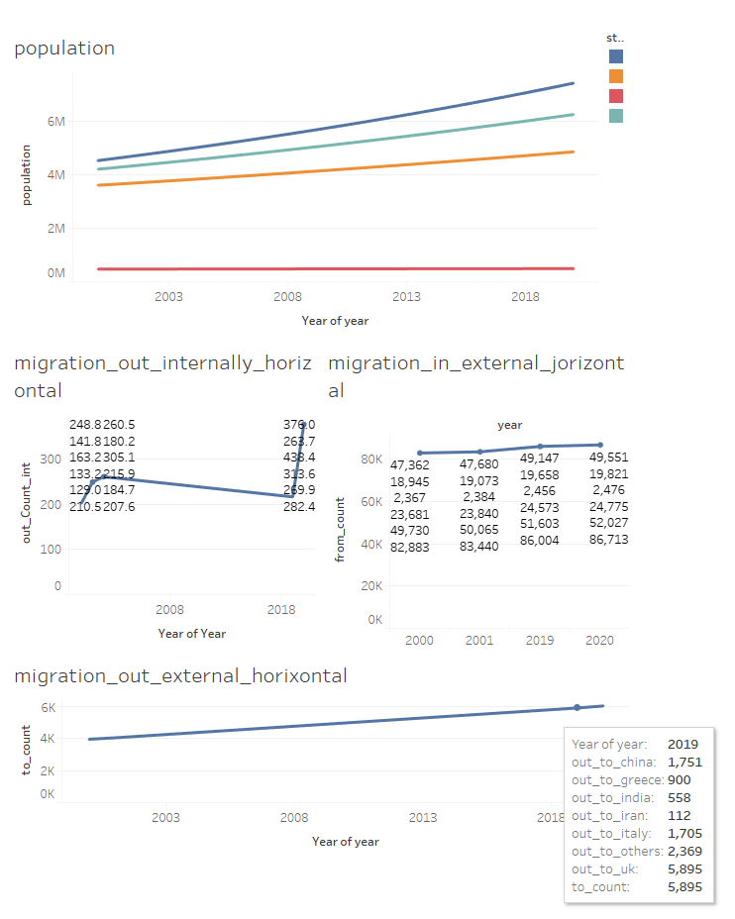

Critique

* Need to hover to see full details
* Need to filter by year

Strength

* Easy to see trends
* All details can be made available

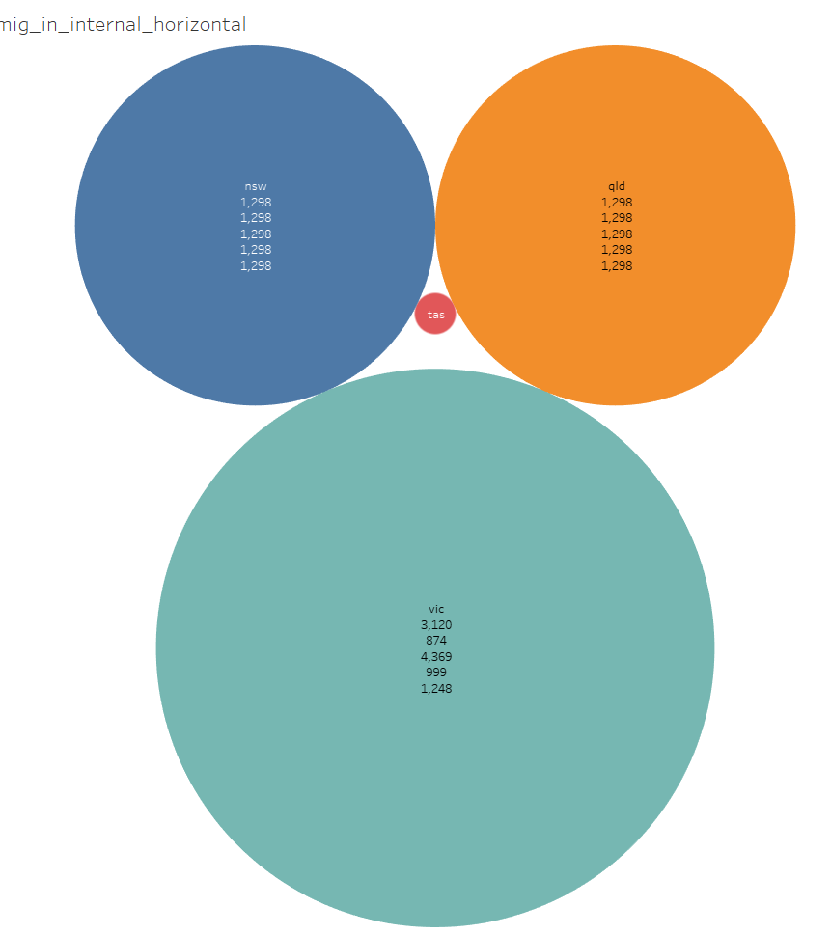

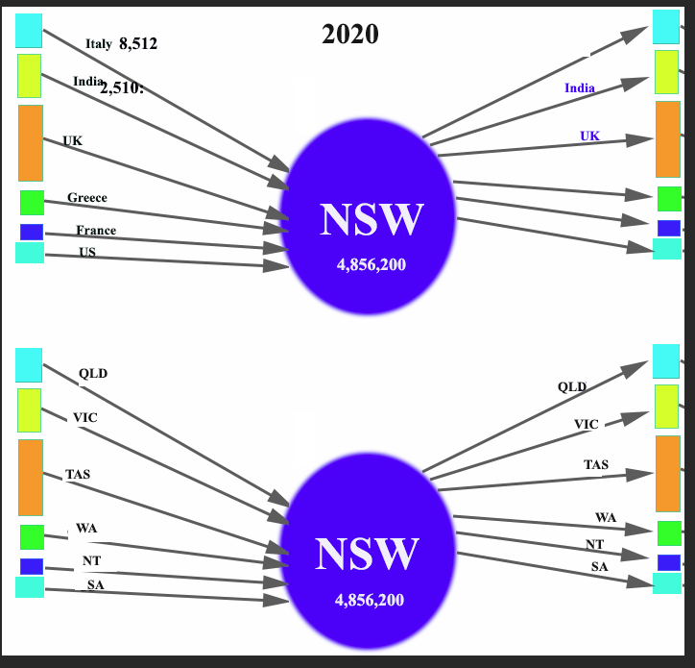

Have same thing for outgoing

